**Automate WhatsApp Messages with Python**

WhatsApp has quickly emerged as the go-to messaging app for over 2 billion active users worldwide and more than 100 billion messages are sent each day. In case user wants to send a message to wish someone on their birthday at midnight or just want to send an alert or notification during your absence, the automation will helps a lot.

WhatsApp messages can be scheduled with the aid of numerous paid third-party apps and bots to automate their messages; however, we can automate this task by writing few simple lines of code with Python and avoid paid subscription bots and apps.

**PyWhatKit**:

Python offers several inbuilt libraries to ease our work, among them PyWhatKit is a library for sending automated WhatsApp messages and It has few other features too.

1. Sending Message to a WhatsApp Group or Contact
2. Sending Image to a WhatsApp Group or Contact
3. Converting an Image to ASCII Art
4. Converting a String to Handwriting
5. Playing YouTube Videos
6. Sending Mails with HTML Code
7. Install and Use

**Installation:**

Install pywhatkit (This will officially support Python 3.8+)



**Code:**

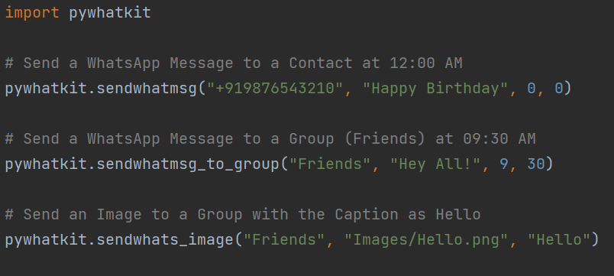

Once you run the code WhatsApp will deliver your automated message/image to specific contact number or a group at the scheduled time.

Automating WhatsApp messages with Python will be a time saving opportunity as you don’t have to send each message to the group manually every time, it is just enough to schedule the pre-written posts and release automatically.

In other scenarios, it is one of the easiest ways to market the business effectively about their offers and services, connecting personally with the customers and customize their preferences to send notifications.